Electromeet Changes
Date: 14-Sep-2017

Table of Contents
Home page 2
#1 2
#2 2

Home page

#1
Move the ‘See Plans’ button below the orange header colour.

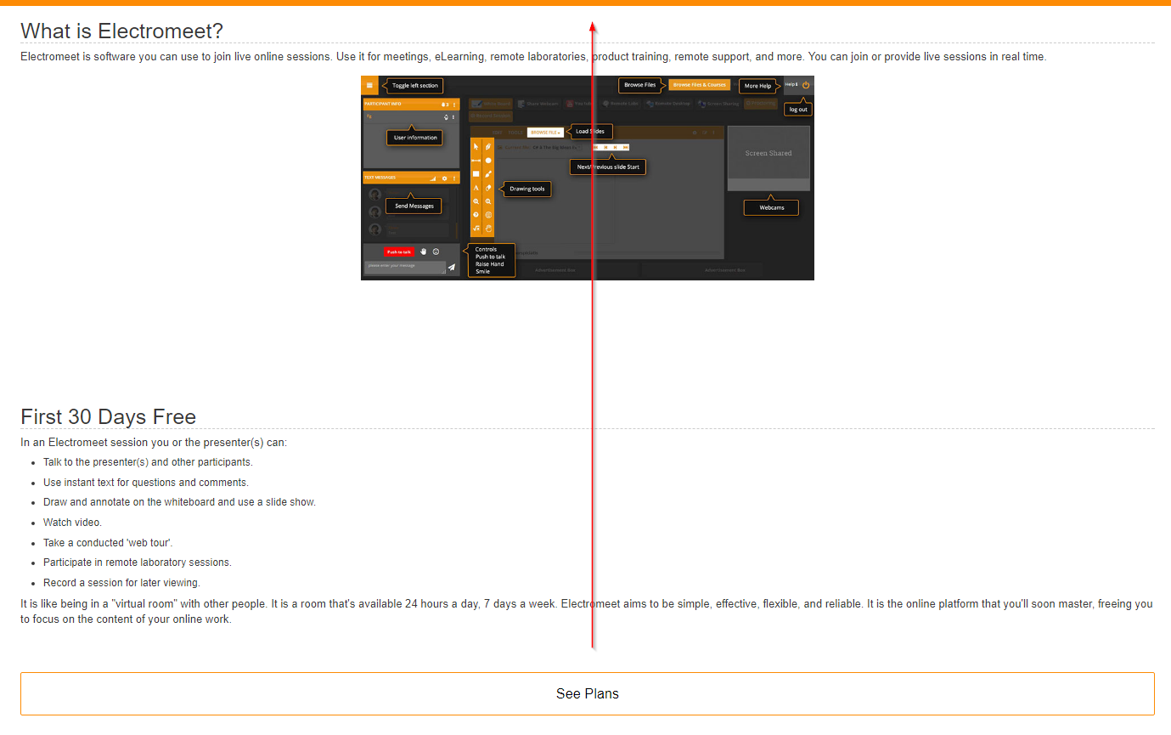
#2

